I, Hendrik Reynders Brough, Id number 8207085047085, being an employee of the Platinum Weekly since March 2013 and married to the Editor Myrtle Brough (maiden Name Douglas) have begun to record these incidents and keep record thereof since our separation on 13 February 2020.

**Wednesday 19 February’2020**

On the 25th of February I was removed from all ot

**Wednesday 17 June’20**

On Wednesday 17 Jun’ 2020 at approximately 10 am, Myrtle along with her friend and Unofficial HR Representative, Marilene Kleynhans approached me at my office and said that I had will withheld information from her and that she would go through my personal files on my Pc (which included but is not limited tto the divorce case between me and her) if I didn’t immediately send her a medical aid Certificate. And even though this was a personal matter and I had been forbidden from having any direct personal contact with Myrtle I had sent her a certificate a week before, so i simply resent the Document

**From:** Reynders Brough <[reynders@platinumweekly.co.za](mailto:reynders@platinumweekly.co.za)>   
**Sent:** Wednesday, June 17, 2020 12:13 PM  
**To:** [news@platinumweekly.co.za](mailto:news@platinumweekly.co.za).  
**Cc:** [ads@platinumweekly.co.za](mailto:ads@platinumweekly.co.za); 'Len - Platinum Weekly Newspaper' <[len@platinumweekly.co.za](mailto:len@platinumweekly.co.za)>  
**Subject:** Fwd: Jou Medies

Hi Myrtle

Soos versoek, hierby aangeheg is my nuwe Mediese sertifikaat soos vir jou aangestuur 11 Jun van my gmail account af.

Ook soos bespreek, sal ek eers vanaand vir jou kan die dokument stuur waar ek my hemiplegia laat aanbring op my belasting, die girl by SARS het vir my gese dat ek dit eers hoef te doen wanneer ek my efiling doen.



***Kind regards***

Description: Logo  [Description: Web](http://www.platinumweekly.co.za/)  [Description: Mail](mailto:reynders@platinumweekly.co.za)  [Description: Facebook](https://www.facebook.com/Platinum-Weekly-Newspaper-365252713584338/)

**Reynders Brough**

**Sales Manager**

Description: xTg89yXTA   014 592 5653  
Mobile-Cell-Phone-icon  081 437 5640  
fax-icon  011 252 6669

**From:** [accounts@platinumpublishers.co.za](mailto:accounts@platinumpublishers.co.za) <[accounts@platinumpublishers.co.za](mailto:accounts@platinumpublishers.co.za)>   
**Sent:** Tuesday, 16 June 2020 20:01  
**To:** [reynders@platinumweekly.co.za](mailto:reynders@platinumweekly.co.za)  
**Cc:** [ads@platinumweekly.co.za](mailto:ads@platinumweekly.co.za); [len@platinumweekly.co.za](mailto:len@platinumweekly.co.za)  
**Subject:** FW: Jou Medies  
**Importance:** High

Reynders,

SOOS PER DIE EPOS OP 13 April, stuur jou nuwe mediese fonds maandelikse betaling.

PROOF DAARVAN, ‘n bief van hulle.

Sodat jou TAX REBAIT korrek kan wees op jou payslips.

Ek verwag jou epos niks later as 17 June 2020 nie.

** PS = Please do not respond to this email address.

Email [news@platinumweekly.co.za](mailto:news@platinumweekly.co.za).

Kind regards,

Logo  [Web](http://www.platinumweekly.co.za/)  [Mail](mailto:myrtle@platinumweekly.co.za)  [Facebook](https://www.facebook.com/Platinum-Weekly-Newspaper-365252713584338/)

**Myrtle Brough**

xTg89yXTA   014 592 9686  
Mobile-Cell-Phone-icon  072 482 6871  
fax-icon  011 252 6669

Contribution to our medical aid was a grace as part of the ongoing divorce whereby she had agreed to switch to her own within a reasonable period, being removed from our medical aid, I assumed she had done it herself. It is also a private matter and of no concern to the company, yet Mrs Lombard accused me of committing Tax fraud and unethical behaviour in a mail which she also BCCed to other members of staff.

**From:** Marilene Kleynhans <sassy@platinumweekly.co.za>   
**Sent:** Wednesday, 17 June 2020 12:36  
**To:** reynders@platinumweekly.co.za; 'Margaret - Platinum Weekly' <ads@platinumweekly.co.za>; myrtle@platinumweekly.co.za; 'Len - Platinum Weekly Newspaper' <len@platinumweekly.co.za>  
**Subject:** FW: Jou Medies  
**Importance:** High

Reynders,

Ek forward vir jou die email van tannie Margaret want haar email deliver nie aan jou nie.

Lees asseblief haar dringende boodskap aan jou hieronder en gee asseblief jou onmiddelike terugvoer.

Marilene Kleynhans

If there is anything else, please do not hesitate to contact me.

Kind Regards,



Logo  [Web](http://www.platinumweekly.co.za/)  [Mail](mailto:myrtle@platinumweekly.co.za)  [Facebook](https://www.facebook.com/Platinum-Weekly-Newspaper-365252713584338/)

Logo [Web](http://www.platinumbushvelder.co.za/) [Mail](mailto:admin@platinumbushvelder.co.za)  [Facebook](https://www.facebook.com/pages/Platinum-Bushvelder/1429519867293128)

**Marilene Kleynhans**

**Bookkeeper**

xTg89yXTA   014 592 3257  
fax-icon  011 252 6669

CONFIDENTIALITY NOTICE: The contents of this email message and any attachments are intended solely for the addressee(s) and may contain confidential and/or privileged information and may be legally protected from disclosure. If you are not the intended recipient of this message or their agent, or if this message has been addressed to you in error, please immediately alert the sender by reply email and then delete this message and any attachments. If you are not the intended recipient, you are hereby notified that any use, dissemination, copying, or storage of this message or its attachments is strictly prohibited.

**From:** [ads@platinumweekly.co.za](mailto:ads@platinumweekly.co.za) <[ads@platinumweekly.co.za](mailto:ads@platinumweekly.co.za)>   
**Sent:** Wednesday, 17 June 2020 12:32 PM  
**To:** [myrtle@platinumweekly.co.za](mailto:myrtle@platinumweekly.co.za); 'Marilene Kleynhans' <[sassy@platinumweekly.co.za](mailto:sassy@platinumweekly.co.za)>  
**Subject:** FW: Jou Medies  
**Importance:** High

**From:** [ads@platinumweekly.co.za](mailto:ads@platinumweekly.co.za) <[ads@platinumweekly.co.za](mailto:ads@platinumweekly.co.za)>   
**Sent:** Wednesday, June 17, 2020 12:31 PM  
**To:** 'Reynders Brough ' <[reynders@platinumweekly.co.za](mailto:reynders@platinumweekly.co.za)>; 'news@platinumweekly.co.za.' <[news@platinumweekly.co.za.](mailto:news@platinumweekly.co.za.)>  
**Cc:** 'Len - Platinum Weekly Newspaper' <[len@platinumweekly.co.za](mailto:len@platinumweekly.co.za)>  
**Subject:** RE: Jou Medies  
**Importance:** High

Reynders,

Jy het Myrtle sonder haar kennis afgehaal van die mediese fonds af. Alhoewel dit erg onverantwoordelik

was van jou om dit te doen, was dit nie teen die wet nie.

Wat teen die wet was is dat jy nie jou werknemer onmiddelik in kennis gestel het dat jou mediese fonds bydrae

verander het nie. So jy het verkeerdelik ‘n tax rebate geclaim wat jou nie toekom nie.

Met verwysing na wat jy bespreek het met Myrtle en Len, minute voor jy hierdie email gestuur het – gehad het.

Jy het hulle terloops gese dat jy geregistreer het as ‘n hemipleeg.

**Stuur asseblief onmiddelik die doktersbrief vir my wat jou gediagnoseer het as ‘n hemipleeg.**

**Aangesien ons as ‘n maatskappy noudat ons daarvan bewus is, sekere voorgeskrewe reels van**

**die arbeidswet moet volg.**

Ek verwag jou onmiddelike terugvoer. Laat weet my as daar ‘n probleem is.

**Margaret Lombard**

In her mail she also stated that I was obligated to immediately send her a doctors letter confirming that I was infact a hemipleeg, as they were never made aware of this fact. I had been working for the company for 7 years with an obvious limp and a cripple hand, yet she insisted on a doctors letter.

Fortunately, I had recently obtained such a letter in order to change my Employment Equity status and claim medical aid benefits for the growing disability.

**From:** [ads@platinumweekly.co.za](mailto:ads@platinumweekly.co.za) <[ads@platinumweekly.co.za](mailto:ads@platinumweekly.co.za)>   
**Sent:** Wednesday, 17 June 2020 16:24  
**To:** 'Reynders Brough ' <[reynders@platinumweekly.co.za](mailto:reynders@platinumweekly.co.za)>; [news@platinumweekly.co.za](mailto:news@platinumweekly.co.za)  
**Cc:** 'Len - Platinum Weekly Newspaper' <[len@platinumweekly.co.za](mailto:len@platinumweekly.co.za)>  
**Subject:** RE: Jou Medies  
**Importance:** High

Reynders,

Ek het ek geen idee gehad dat jy ‘n gebore hemipleeg is nie.

So jy doen dit vir geen ander rede behalwe: ‘omdat dit voordelig is’ nie.

Sover ek weet is jy blakend gesond en het jy gereeld whatsApps en emails gestuur om ons almal in te lig van die goeie tye wat jy opgestel het in die vele trapfietswedrenne waaraan jy deelgeneem het.

Is daar enigeiets spesifiek wat jou dan as ‘hemipleeg’ nou beinvloed wat jou nie voorheen beinvloed het nie?

Ons was geensins bewus daarvan nie en het ook geen spesifieke voorsiening daarvoor gemaak, of

tegemoetkominge daarvoor gehad nie.

Is daar enigiets spesifiek wat jou dan as ‘hemipleeg’ enigsins gaan beinvloed om nie jou werk te doen soos toe jy by ons begin werk het nie?

Margaret Lombard

**From:** Reynders Brough <[reynders@platinumweekly.co.za](mailto:reynders@platinumweekly.co.za)>   
**Sent:** Wednesday, June 17, 2020 3:50 PM  
**To:** [ads@platinumweekly.co.za](mailto:ads@platinumweekly.co.za); [news@platinumweekly.co.za](mailto:news@platinumweekly.co.za)  
**Cc:** 'Len - Platinum Weekly Newspaper' <[len@platinumweekly.co.za](mailto:len@platinumweekly.co.za)>  
**Subject:** RE: Jou Medies

Goeie middag julle.

Soos julle weet is ek ‘n gebore hemipleeg.

Ek het besluit om dit amptelik te registreer by SARS omdat dit voordelig is.

Die dame by SARS het my vir my hierdie dokumente gegee om deur my Dokter te laat voltooi wat ek dan saam met my e-filing later in die jaar sou indien.



***Kind regards***

Description: Logo  [Description: Web](http://www.platinumweekly.co.za/)  [Description: Mail](mailto:reynders@platinumweekly.co.za)  [Description: Facebook](https://www.facebook.com/Platinum-Weekly-Newspaper-365252713584338/)

**Reynders Brough**

**Sales Manager**

Description: xTg89yXTA   014 592 5653  
Mobile-Cell-Phone-icon  081 437 5640  
fax-icon  011 252 6669

Upon receiving the Doctors letter, Mrs Lombaard claimed to have been unaware of any disability, stating that I can’t be disabled and cycle. Unlike the email in which she accused me of committing tax Fraud, she didn’t bcc other members of staff in the last mail.

**Monday 6 July**

On Monday, 6 July at approximately 12:00, one of my colleges, Gian Webb, showed Symptoms of a high fever and was sent home as a precaution.

The following day, one of the other graphic designers, Androhan Kleynhans, Marilene Kleynhans, the Bookkeeper and impromptu HR representative’s son, was also absent. Androhan, who share the same office with Gian and two other employees, was absent. We were informed that he had simply taken a few days leave to spend with his girlfriend, but this in itself was suspicious because in the 7 I’ve worked for the Platinum Weekly, I have very seldomly seen staff being granted leave on such short notice especially over a “D-day” (day of going to print) and less than two weeks earlier both Gian and Androhan complained that with the new overtime system, neither of them, have any leave days left

(a fact that can be checked)

Throughout the week, I directly contacted Gian as well to check up on his health and to confirm that he did not have any symptoms of Covid-19. Here is the WhatsApp Communication between us. 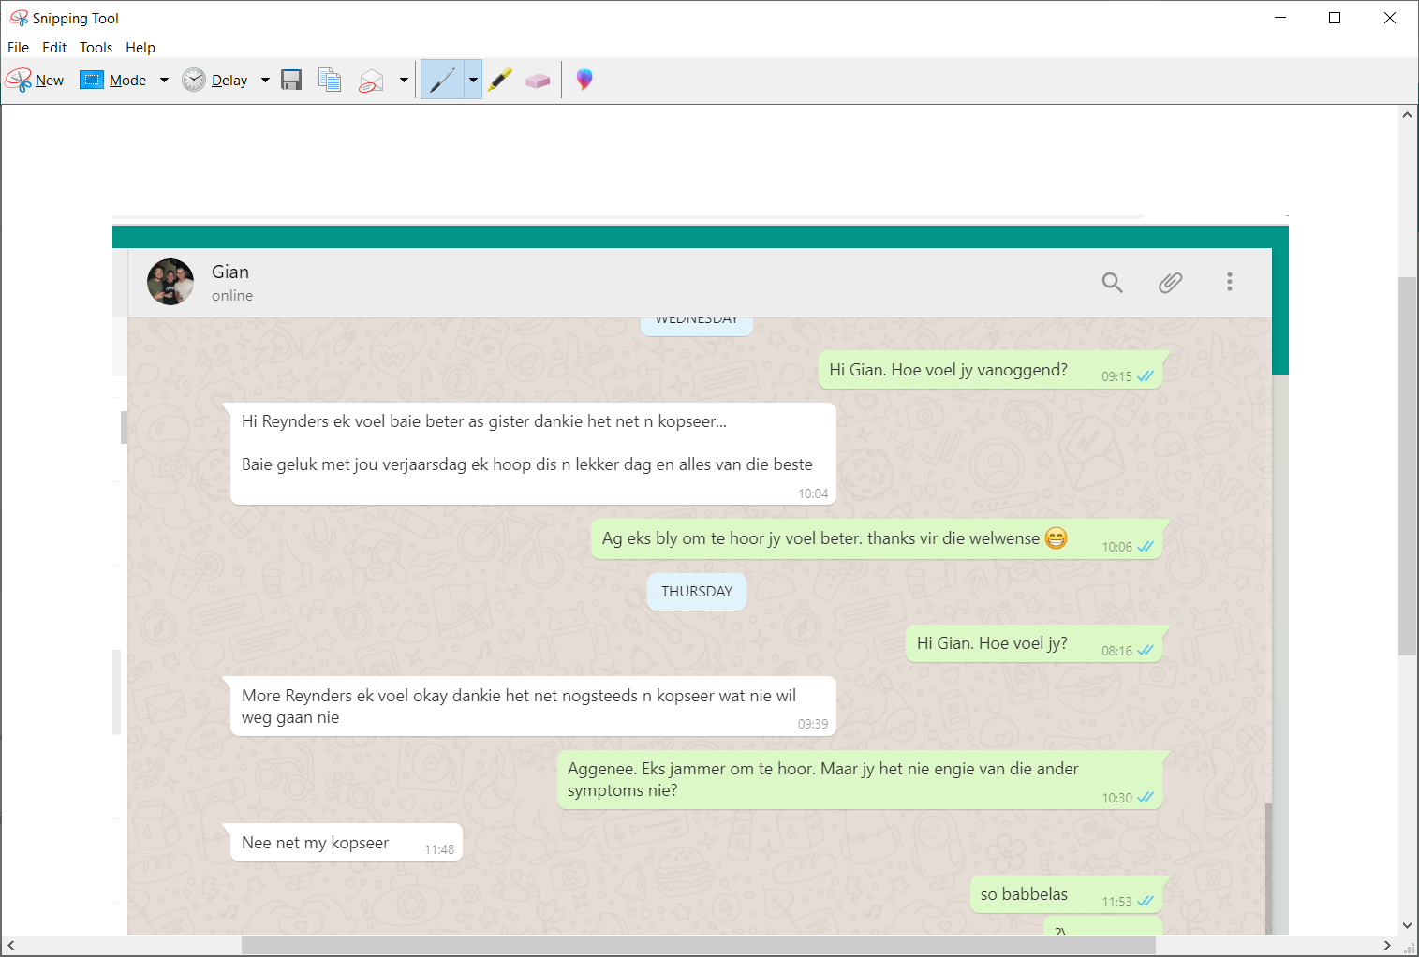

It was important for me to check, as since being forcefully evicted from my home By Myrtle and her Parents, Len and Margaret Lombard, I have been staying in my Parents outroom (cottage). And as both my parents are over 61 it would be necessary to take extra precaution if we had been exposed to covid-19

Friday 10 July

On Friday 10 July 2020, at approximately 9:45am Myrtle Summoned the entire office to a meeting, whereby she informed us that Gian had in fact tested positive for Covid-19 and that was the reason why they had sent Androhan Kleynhans home on Tuesday was in fact a precautionary measure. I was visibly upset by the fact that management had decided to send both Gian and Androhan home as a precaution but decided to not even inform us of the fact that we had possibly been exposed to Covid-19, and could have spread it to our own homes.

I asked Myrtle why she had chosen to send only Androhan home, to which she answered that they were in unusually close contact with each other but they didn’t have to inform the rest of us about the possible contamination until they were sure, which was now.

After the meeting Myrtle and her office friend and impromptu HR representative, Marilene Kleynhans came to my desk again to discuss the matter further. I told them that I didn’t wish to speak to them about private matters without additional witnesses so I called to other personnel who were close by, Jacqueline Rademeyer, graphics Designer and Lindi Ferreira, sales Representative.

Again Myrtle stated that they had let Androhan go home as a precautionary act and legally didn’t have to inform us. I asked her if she couldn’t just say that they had sent Androhan home for a week to be with his girlfriend rather than that they had chosen to share potentially life threatening information with only some members of staff. She could not.

she took this opportunity to accuse me cancelling her medical aid as a malicious act and shouted how glad she is that she found out I had cancelled her medical aid before storming off again.

At 10:15, Margaret Lombard, owner of the Platinum and wife to Len Lombard, managing director of Platinum Publishers posted this on our office WhatsApp Group. 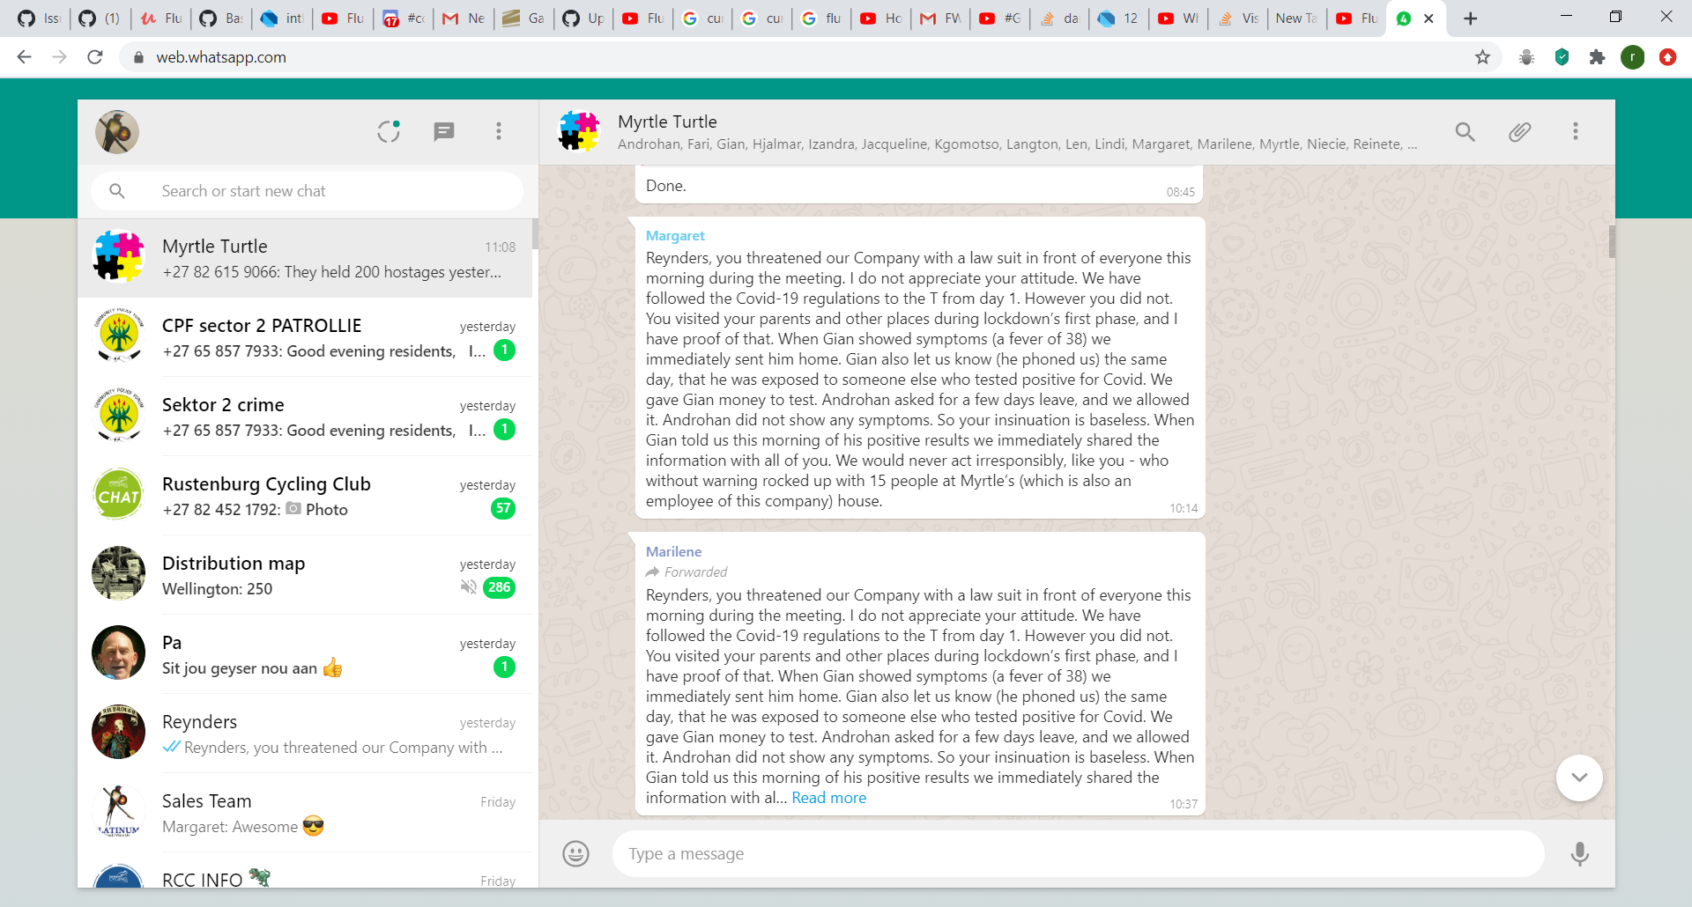

Here it is more visible. 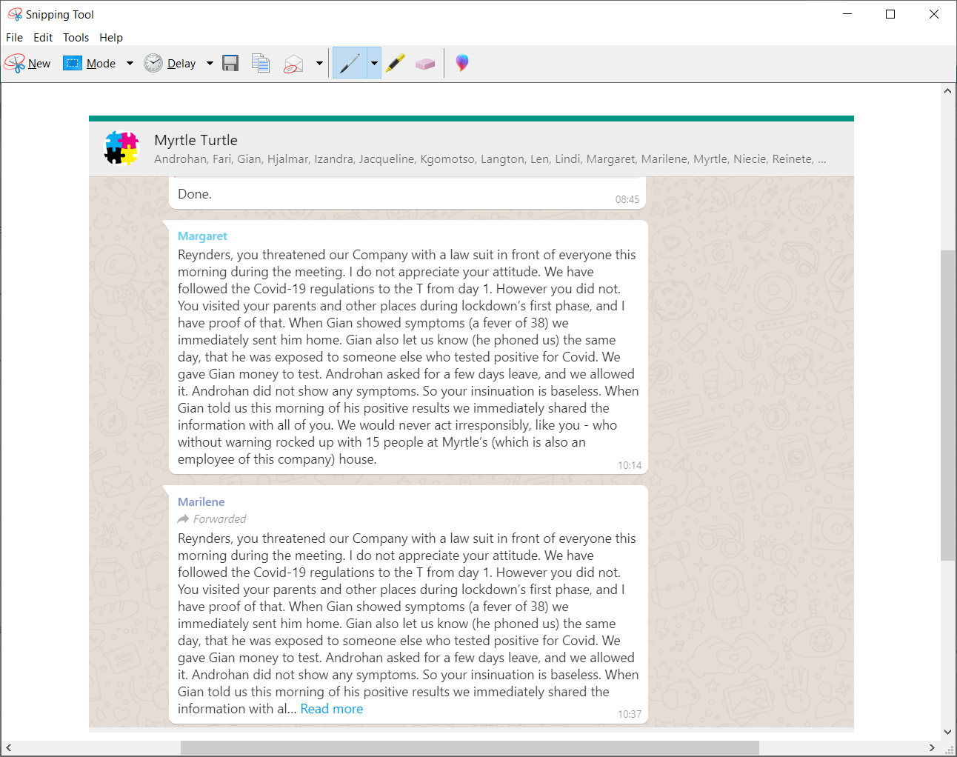

I believe that this was posted by Margaret, who was not at the mornings meeting as part of a larger attempt at character assassination. I also belive it was then reposted by Marilene Kleynhans, the Bookkeeper and unofficial HR Representive, in her capacity as HR Representative to undermine y role as Sales Manager, especially to staff who weren’t at the meeting.The resulting responses from staff who weren’t at the meeting.

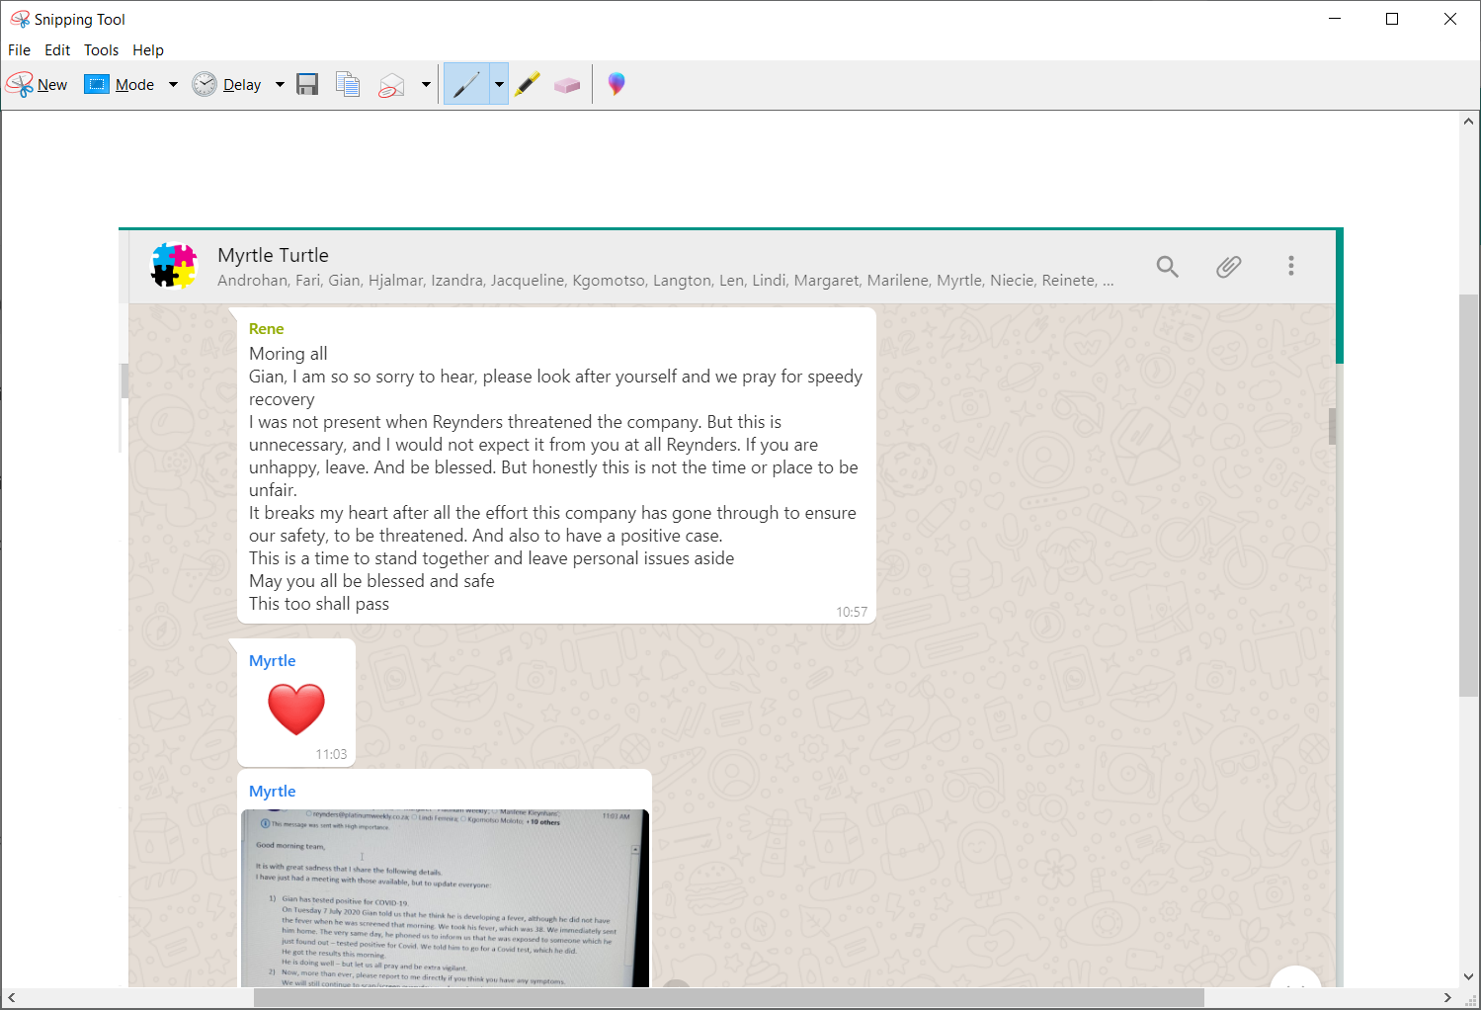

Again, instead of correcting his staff and reiterating the facts, this was Mister Lombard’s response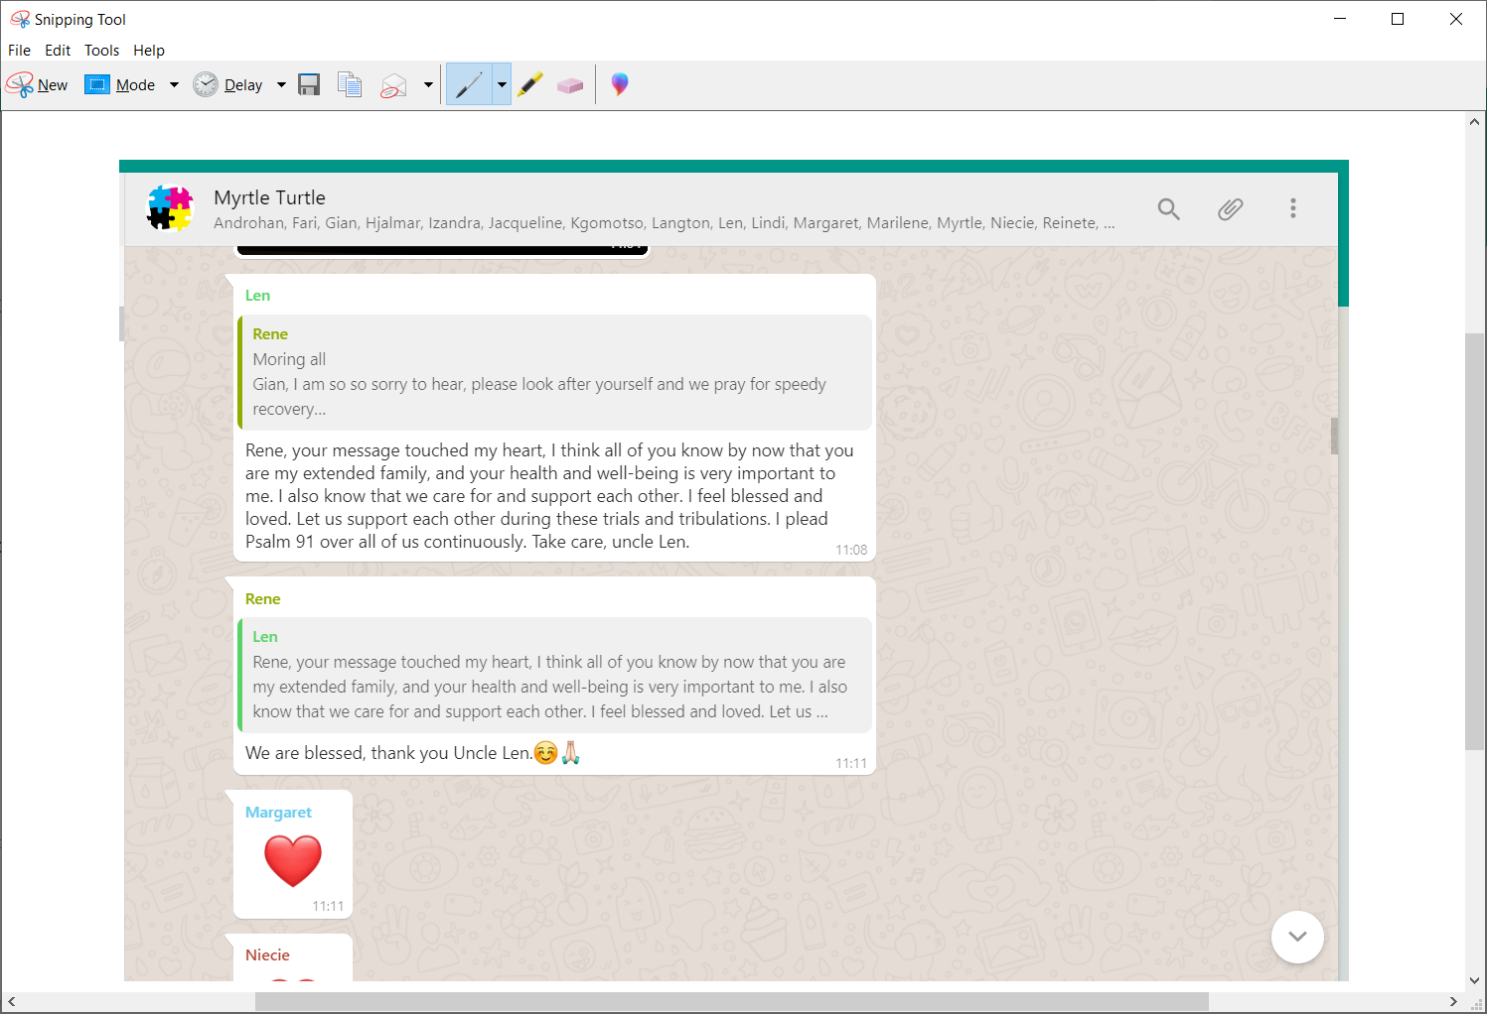

It is worth noting that Mister Lombard was also absent from the meeting, as saw Mrs Lombard.

Again, another sales member who is based in Thabazimbi felt it worth raising their opinion. 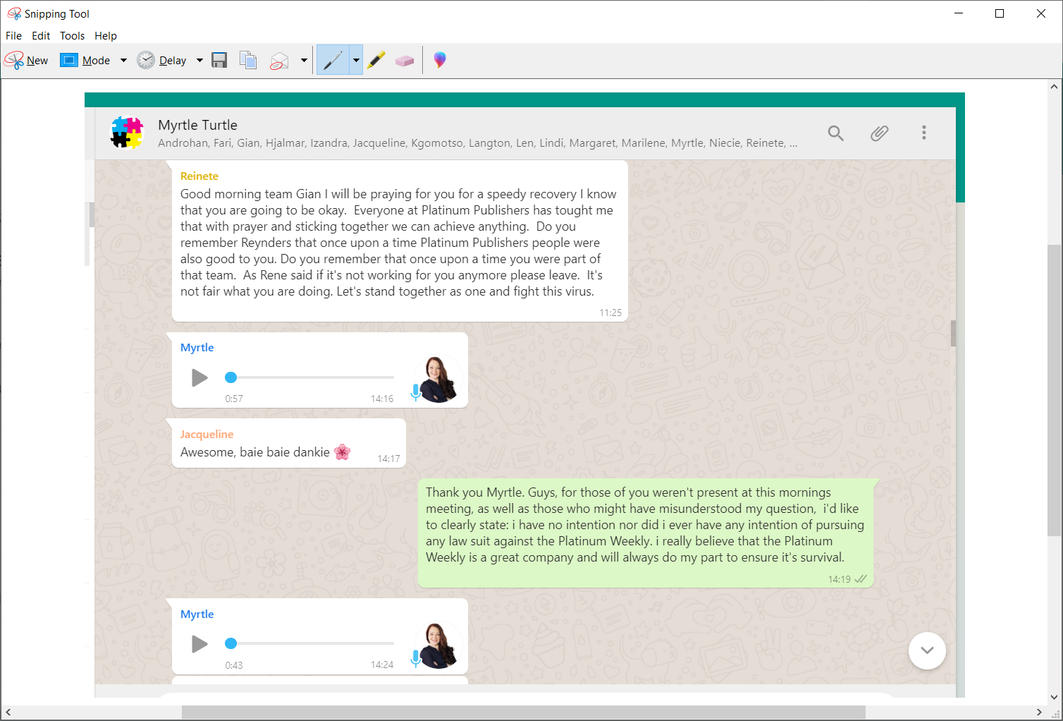

At this point i felt that i was being attacked from members of staff who do not work from the same office but who were aparently informed by rumours, such as personal accusation Mrs Lombard had snuck into work WhatsApps intended for the entire company, as she had done on several previous occasions.

On Saturday, 11 July, Mrs Lombard posted this update regarding actions that they had taken once they had known of Gians exposure to Covid-19